**WIND LAW PrOposal FOR AIrCRAFT CONTROL IN TURBULENCE**

**Jérôme Bazile\***

*\*Airbus Opération S.A.S,*

316, Route de Bayonne, 31060 Toulouse cedex 09

*France*

**ABSTRACT**

**In the frame of the *“Aircraft Control in Turbulence”* this article is highlighting an innovative methodology for the passenger’s comfort improvement and aircraft dynamic loads reduction.**

**Actually, this methodology has been developed by using the linear *“Quasi-Static”* short period model and lies in the coupling of the lift and pitching moment equations. This coupling has been made possible by the analytical *“Aerodynamic Cross-Products”* identification based on the Doublet Lattice method in the low frequency domain, even though never mentioned in flight mechanics handbooks.**

**Then, based on this preliminary analytical identification, this coupling led to a unique equation, seen as of “Energy” type and named *“Fundamental Equation of Aircraft’s Dynamic”* or *“Equation of Conservation”.* This fundamental equation, at the heart of Aircraft Dynamics, is a function of flight mechanics parameters such as, Angle of Attack derivative, pitch rate and pitch rate derivative, but also a function of several fundamental aerodynamic *“Neutral points”* which are governing the overall Aircraft Dynamic response.**

**In a first step, this equation has been highlighted with only the elevators and ailerons control surfaces for basic control laws tuning and then in a second step, the wind effect has been introduced leading to the fundamental equation with both control surfaces and wind effect as model inputs. Finally, it has been possible to define a global control surface order that enables to minimize the wind effect in the aircraft dynamic response.**

**In a first part, this article presents the “keys steps” of the theoretical development leading to the *“Fundamental Equation of Aircraft Dynamics in Turbulence”*. In a second part, this concept is illustrated by the linear short period model time responses, with a focus on load factor time histories.**

**This preliminary study constitutes a first step towards a more realistic approach and more complex simulations by considering on the one hand an aeroelastic model with rigid and flexible modes and on the other hand by defining thisspecific control law in turbulence accounting for actuators characteristics, time delays.**

**Introduction.**

In the frame of the *“Aircraft Control in Turbulence”* this article is highlighting an innovative methodology for passenger comfort improvement and aircraft dynamic loads reduction. However, this one doesn’t pretend to cover all the aspects of this longitudinal wind law with the loads assessment in the whole flight domain but must be seen as the beginning of a long story by explaining the basic principles of this law based on a linearized rigid short period mode model. Now, this article is divided into two main parts, the first part deals with of the theoretical aspects and the second parts presents transfer functions & time simulation results.

**I/ Wind Control law identification based on the Aircraft dynamics Fundamental Equation.**

In this first part, the main purpose is to identify a wind control law. For this we will base on the linear short period mode model from which we will establish the so called ***“Aircraft Dynamics Fundamental Equation*”**. And, from this equation, we will highlight a possible control law, also called longitudinal wind law. So, the linear short period mode model is:

* **Lift equation:**



=



* **Pitching moment equation:**



=



+



with  and  respectively inertia and reduced mass.

In these two equations with highlighted the dependence of aerodynamic derivatives on center of gravity position. We also deliberately decided to keep the aerodynamic derivatives in pitch rate variation effect, most of the time often neglected. Now at this stage, we propose to identify the ***“Aircraft Dynamics Fundamental Equation”*** without the wind input. The wind will be introduced later in the article.

**1/ Aircraft Dynamics Fundamental Equation identification.**

Now to get the ***“Aircraft Dynamics Fundamental Equation”*** we are going to multiply the lift equation by the pitching moment derivative in angle of attack effect and the pitching moment equation by the lift derivative in angle of attack effect and then subtract the lift equation from the pitching moment equation. The main driver of this way of doing was to eliminate the Angle of Attack parameter.

This mathematical operation does not present any real difficulties, we obtain the following resulting equation expressed as a function of the different aerodynamic state variables and the elevator input, so:



=



+



+



In this equation, we can observe, the presence of some ***“Aerodynamic Cross-Products”***, which we will obviously determine. To do this, we will base on unpublished work carried out a few years ago, relating to the identification of rigid aerodynamic gradients using the ***“Doublet-Lattice Method”*** [2] in the range of very low frequency. Therefore, through this method, it was possible to identify the analytical expression of the different longitudinal aerodynamic gradients as a function of the center of gravity position, in their linear domain, which are as follows:

* **Lift derivative in pitch rate effect:**



* **Lift derivative in pitch rate variation effect:**



* **Pitching moment derivative in Angle of Attack effect:**



* **Pitching moment derivative in Angle of Attack variation effect:**



This expression can also be written using the following ratio: .

So, by replacing, we obtain:



With  defined as the pitching moment derivative in Angle of Attack variation effect at the neutral point.

* **Pitching moment derivative in pitch rate effect [1].**



With  defined as the pitching moment derivative in pitch rate effect at the neutral point.

* **Pitching moment derivative in pitch rate variation effect.**



With  defined as the pitching moment derivative in pitch rate variation effect at the neutral point.

* **Pitching moment derivative in elevator angle effect.**



This expression can also be expressed with the following ratio: .



With  defined as the pitching moment derivative in elevator angle effect at the neutral point.

Therefore, with all these ingredients we can identify the ***“Aerodynamic Cross-Products”*** into the equation on the previous page, so:









Now, by inserting these different ***“Aerodynamic Cross-Products”*** into the resulting equation and dividing it by the lift derivative in angle of attack effect we obtain the ***“Aircraft Dynamics Fundamental Equation”***which is:



+



In this equation, we can observe on the one hand the pitch rate effect, the pitch rate variation effect, the angle of attack variation effect and the elevator input without direct angle of attack effect and on the other hand we can observe in front of each state variable a term depending of the center of gravity position, noted  as:

* **The  is defined as an aerodynamic inertia term:**



The solution of this equation shows that it exists a position of the center of gravity for which this inertia term changes sign. To my knowledge this term has never been identified in flight dynamics literature.

* **The  is defined as an aerodynamic stiffness term:**



The solution to this equation gives the limit position of the center of gravity beyond which the model is dynamically unstable, the model diverges. Furthermore, for a stationary resource, this point coincides with the position of the maneuver point, which cancels the ***“elevator angle per g”*** function.

* **The  is defined as an aerodynamic damping term:**



The solution of this equation gives the position of the point beyond which the linear short period model responds as a pure first order system. The position of this point is close to the position of the point for which the reduced damping is equal to unity.

After having defined these three different terms, the expression of the ***“Aircraft Dynamics Fundamental Equation”*** can be reduced into the following very simple form:



**Comment:**

We can observe the remarkable nature of this equation insofar as it contains all the dynamic properties of the linear short period mode model. Looking at it a little more closely, this equation can be compared to an ***“Energy”*** type equation insofar as, for the same order of the elevator but for two different center of gravity positions, the left part of this equation is conserved, it therefore remains constant. This equation shows that our linear flight mechanics model is a “non-dissipative system” and, for an elevator order, all the energy is broken down into the response of the different states but the overall energy of the system remains constant. We will not demonstrate it in this article, but this equation also represents the characteristic polynomial of the short period mode model in which we have the reduced damping as well as the square of the pulsation of the short period mode. These two quantities being expressed function of and  previously mentioned.

**2/ Aircraft Dynamics Fundamental Equation with elevator and wind input.**

Now to introduce the wind in the ***“Aircraft’s Dynamics Fundamental Equation”*** we are going to define the following *“wind”* state space parameters, noticed:  and , so:

 

 

**Nota:** The and  terms model the wind effect on the pitch rate and pitch rate derivative parameters of the aircraft.

In the  expressions, we consider the wind time delay propagation, noticed , between the aircraft’s nose and the center of gravity location and defined as. Now by introducing the *“wind”* parameters only in front to aerodynamic terms and not in front inertial terms, then we obtain the following equation:by grouping the “input” terms in the right side of the equation, the ***“Aircraft Dynamics Fundamental Equation”*** with the wind and the elevator inputs, is:



+



=



Equation, that can also be expressed with  and  previously defined, so:



=



In the above equation, we can observe the***” non-linear”*** wind derivative input. Therefore, for the analytical transfer function calculation linked to the linear model dynamic responses exploration, we propose to linearize using the 1st order Taylor expression as follow:



Now, by introducing this linearized term, the ***“Aircraft Dynamics Fundamental Equation”*** takes the following form, that we will consider in the next step of this paper:



=



With the term  defined as the propagation time delay between aircraft nose and the neutral point

**3/ Elevator order identification for Aircraft control in Turbulence.**

Now, based on the previous equation we can define a first strategy for controlling the aircraft motion in presence of wind using the elevator only, by writing:



And finally, we can highlight and analytical expression of the elevator order, so:



**Nota:**

In the above expression, we can observe that the elevator order only depends on the first and second wind derivative, but not on the wind itself! We can also notice that the coefficients in front of the first derivative and second derivative of the wind are independent of the center gravity location, but only of the Mach number. To extend the purpose, we could also define a second strategy to control the aircraft motion by introducing external and/or external ailerons according the following expression:



With the possible following link between the ailerons and the elevator order as:

**4/ Assumption on elevator order for the simulation.**

In the following part, we are going to simulate the short period mode model in the frequency domain and in the time domain with this “Wind Law” by considering only the elevator order, such that:



In the above expression, the gain has been introduced to optimize the load factor reduction. Then, for the simulations, the term linked to the second order wind derivative has been removed to avoid high frequency content in the transfer functions, that are not necessarily physical. Therefore, under this last hypothesis, the analytical expression of the elevator order for simulations is such that:



**Nota:**

For consistency, we will also remove the terms associated to the second order wind derivative in the lift and pitching moment equation

At the end of this first theoretical part, we have established the ***“Aircraft Dynamics Fundamental Equation”*** from which we have been able to identify an elevator order to control the short period mode model responses in the wind. *Therefore, the following questions arise*: Is this strategy efficient? And if so, which benefit can we get from reducing the load factor and/or dynamic loads? To answer this question, in the second part we will simulate the short period mode model by focusing on the load factor time responses along the fuselage.

**II/ Short period mode model simulation equipped with the wind law.**

In this second part, we will simulate the linear short period mode model such as:

* **Lift equation :**



+



* **Pitching moment equation :**



+



Then, related state-space model is:



With the state-space vector defined as, the input vector defined as and the output vector defined as  , as:







At this step of the study, the frequency and time simulations will be carried out **“in an ideal world”**, that is to say without actuators to avoid complicating the study and the results analysis. But before moving on to the simulation results, we propose to determine the analytical expression of the optimal gain.

**1/ Optimal  gain identification.**

To determine the optimal gain, we will consider the analytical load factor transfer function expression at the center of gravity location with respect to the wind derivative including the wind law, as follows:



With  defined as the short period mode model characteristic polynomial. It can be observed in this second order transfer function that the coefficients of the numerator are depending on the gain. We will not give here the and expression, but only the coefficient, representing the transfer function static gain as follows:



Now we can notice, that can be cancelled for a specific value of  gain, noted , such as:



As we have demonstrated it, this particular analytical expression cancels the static gain of the load factor transfer function with respect to the wind derivative, but also cancels the derivative of the load factor transfer function with respect to the wind at frequency equal to zero. Now, based on the above analytical expression, we can determine the optimal elevator order expression, noticed, as:



**Nota:**

This very simple analytical expression shows the optimal elevator order is independent of the center of gravity location and only dependent of the momentum aerodynamic derivatives  and  at the neutral point for the considered flight point.

# 2/ Short period mode model response.

The calculation has been performed for a civil transport Aircraft at VC and for a standard cruise altitude.

# 2-1/ Responses analyses in frequency domain.

To show the effect of the wind propagation time delay from the aircraft nose to the center of gravity position, the two figures below respectively present the load factor transfer function at the center of gravity with respect to the wind and the wind derivative. We can observe that the effect of the time delay begins to become noticeable around 0.3 (Hz) knowing that beyond 1 (Hz) the blue and red curves no longer make sense due to a law fidelity Short Period mode model for high frequencies.

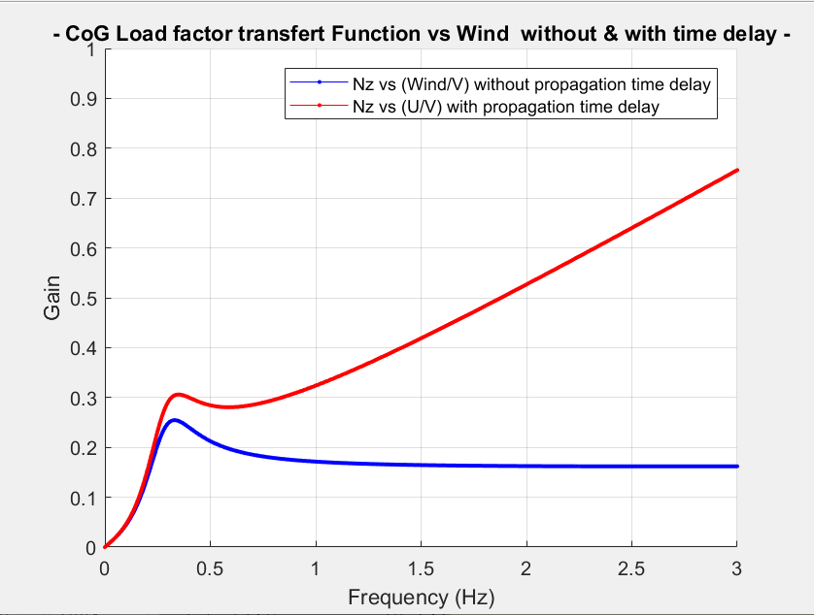 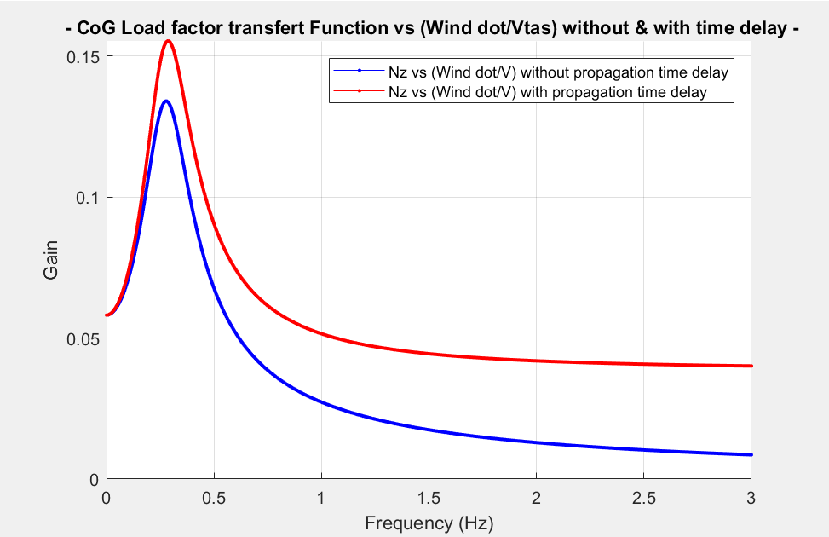

* **Wind law effect on the load factor transfer function.**

The two following figures respectively present the load transfer function at the center of gravity with respect to the wind and the wind derivative with the wind law for  and for  related to optimal elevator order previously defined.

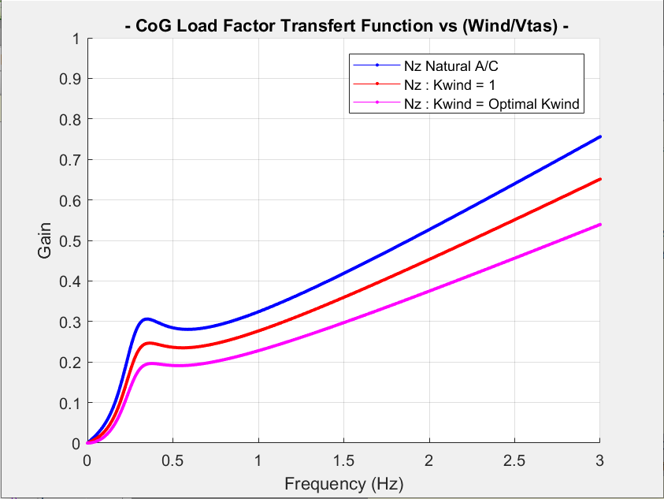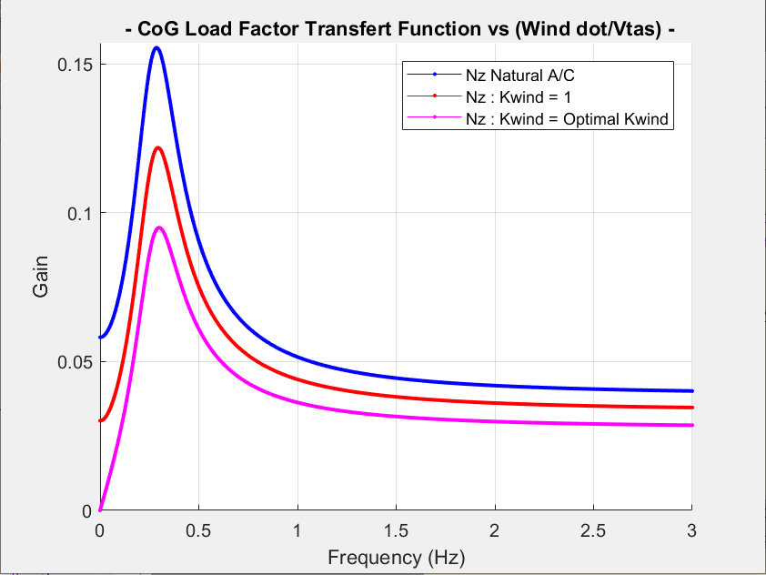

On the right-hand figure, we can observe that the optimal gain has indeed canceled the static gain of the load factor transfer function with respect to wind derivative and on the left-hand figure the derivative of the load factor function transfer with respect to the wind is indeed zero at zero frequency, mentioned by the magenta arrow. From then, we observe a weakening of the transfer function leading to a consequent gain reduction in the low frequency domain, compared to the natural aircraft response, above all visible in when calculating the Power Spectral Density in Continuous Turbulence.

# 2-2/ Response analysis in time domain.

We have simulated the short period mode model time response with a discrete gust tuned for 0.5(Hz) and an amplitude of 7 degrees of wind.

* **Wind law effect on the load factor time responses.**

The following figures show the load factor time history for three sensors located along the fuselage axis: On the front part, at the center of gravity and on the rear part.

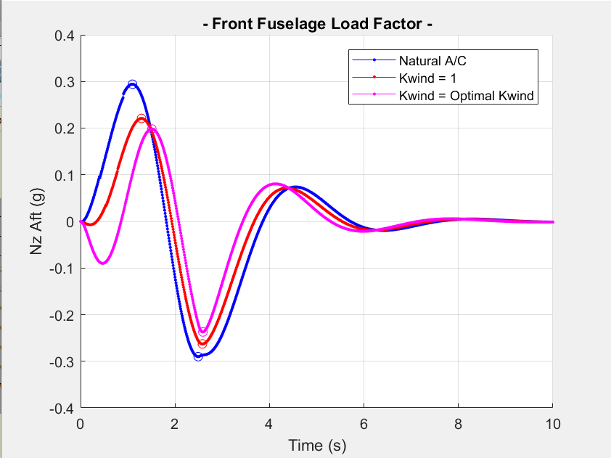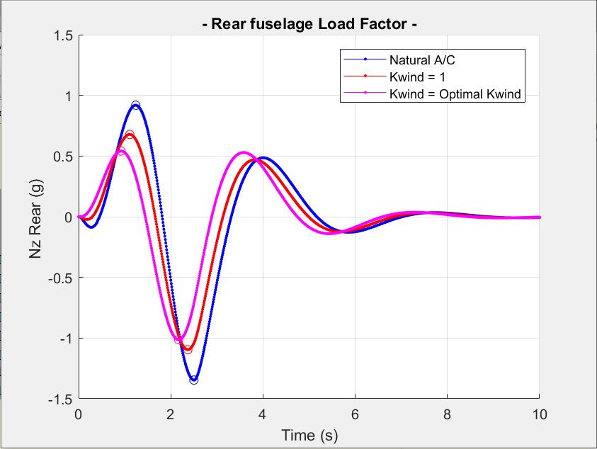

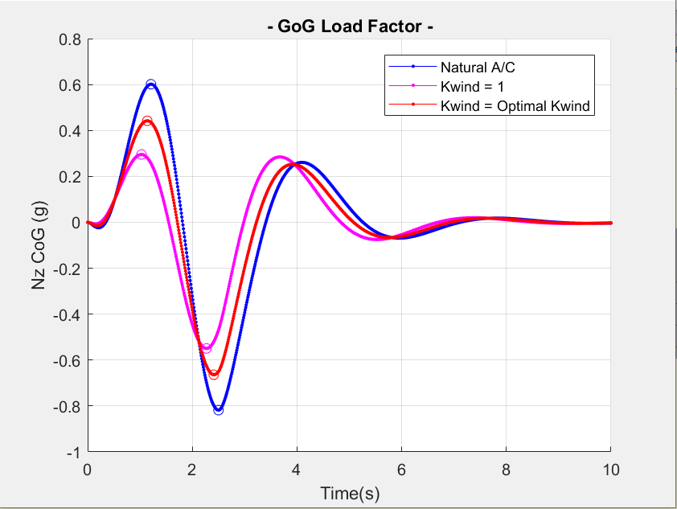

On these figures, we can observe that the optimal elevator order made it possible to significantly reduce the maximum and minimum value of the load factor value compared to the natural aircraft. We nevertheless observe an **“over-shoot”** of the optimal response compared to the natural aircraft around 3(s) for all three sensors along the fuselage.

* **Elevator time response**

This figure presents the elevator order:

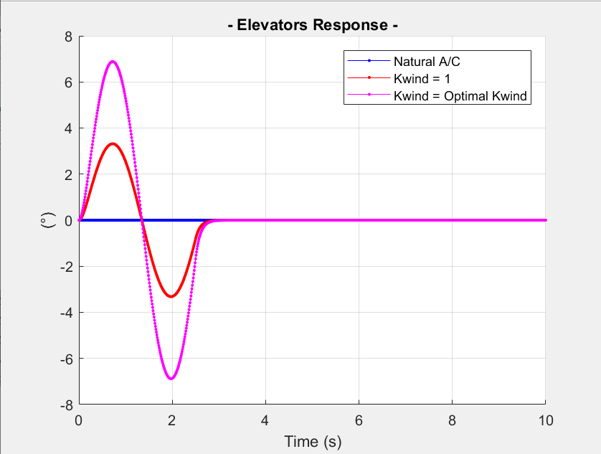

Regarding the optimal elevator order, we can observe that the maximum value is 7 degrees for a load factor reduction of 50 (%) at the center of gravity, of 30 (%) at the front and 40(%) at the rear fuselage.

* **Vertical Aircraft displacement.**

This figure presents the vertical aircraft displacement at the discrete gust occurrence.

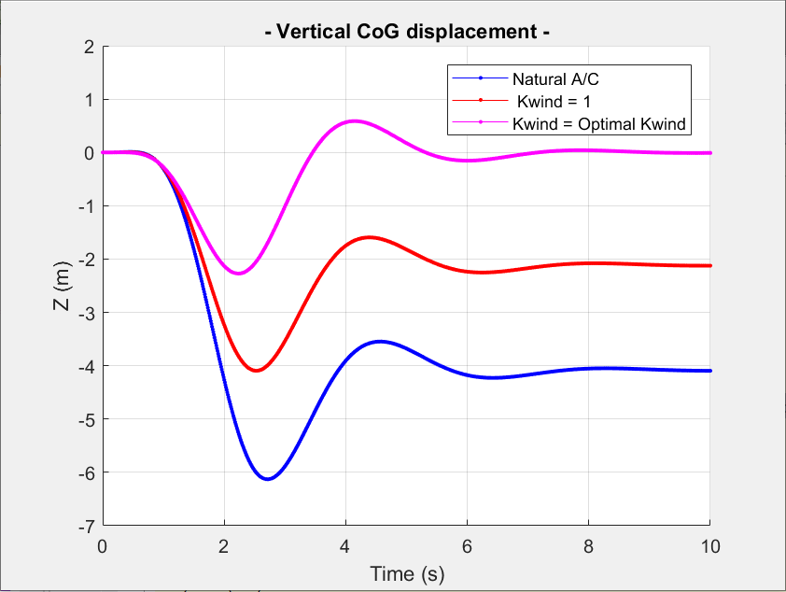

We can observe that, to cancel the gust, the model has a dive movement and that it subsequently repositions itself naturally to its initial position, without the help of any system. This behavior is explained by the zero value of the static gain of the load factor transfer function with respect to wind derivative which by a double integration represents the vertical displacement.

* **Maximum and minimum Load factor value optimization.**

The last figure presents the maximum and minimum Load factor value optimization at the center of gravity function of the gain.

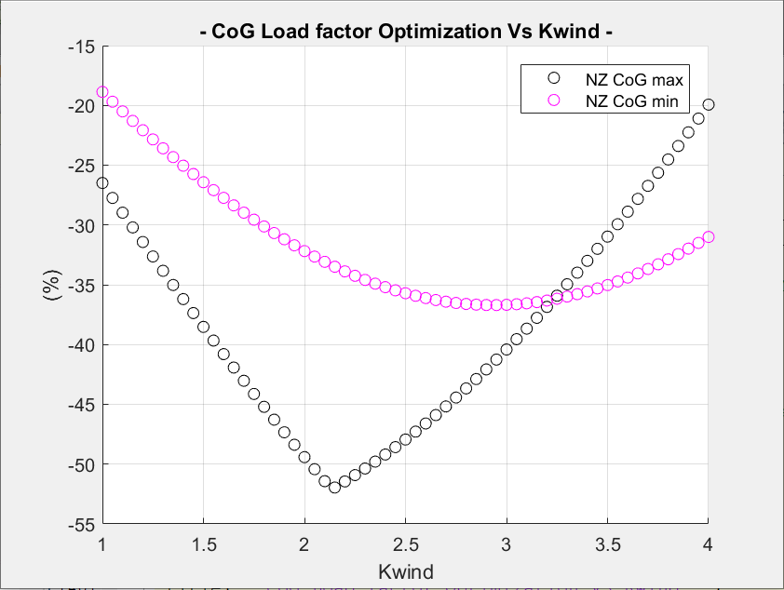

We can observe on this curve, a reduction of 50 % - compared to the natural Aircraft - of the maximum load factor level at the center of gravity for . The numerical calculation of the gain based on the analytical expression seen previously, is . This curve clearly confirms the major role of the static gain in the load factor time response. For the rear part we obtain a similar curve, while for the front part, the optimal value of the gain is rather around probably due to the pitch rate derivative contribution more pronounced for the front part than for the rear part of the fuselage.

At the end of this second part, we were able to observe on the temporal simulations a real effectiveness of this wind law with the optimal elevator, however it remains in an ideal world. The most remarkable figure seems to be the vertical displacement of the model which shows that it naturally returns to its initial position after the gust occurrence.

# III/ Conclusion.

To carry out this study we relied on significant work to simplify the flight mechanics equations formalism, in particular through the ***“Aerodynamic Cross-products”*** identification, which made it possible to express the ***“Aircraft Dynamics Fundamental Equation”*** with these three characteristic points. Then, by manipulating this fundamental equation, we were able to determine a first strategy to control the linear model response in the wind via the analytical expression of elevator order only depending of the aerodynamic characteristics at the flight point. It was also shown that elevator order could be optimized by a gain which made it possible to counter the wind effect on the load factor with efficiency, as a 1st step in an ideal theoretical world.

From a practical point of view, the major difficulty remains linked to the identification of the wind derivative, because to guarantee an optimal effectiveness of this law, it is necessary to know this derivative as precisely as possible and in advance for the alleviation system. The availability of this information is a real challenge for this type of “wind law”. However, studies remain to be carried out by gradually making the model of this law more and more complex, in particular by adding different time delays on the acquisition and transmission chain of the control elevator order, by adding actuators, by adding of additional control surfaces and by using a flexible model in order to see the effect of this wind law on dynamic loads level in the flight domain.

**Références:**

[1] Jérôme Bazile *“New analytic formulation of the manoeuvre point of a flexible aircraft for the dynamic stability analysis”* 2nd european conference for aerospace sciences (eucass) July 2007.

[2] Edward Albano and William P. Rodden *“A Doublet-Lattice Method for Calculating Lift Distributions on Oscillating Surfaces in Subsonic Flows” Northrop Corporation, Norair Division, Hawthorne, Calif.*

**Notations:**

SPMM: Short Period Mode Model

: True air speed.

: Reference length.

: Reference surface.

 : Pitch rate.

 : Pitch rate derivative.

 : Angle of Attack.

 : Angle of Attack derivative.

 : Elevator angle.

 : Aileron angle.

 : Lift aerodynamic derivative in angle of attack effect.

 : Lift aerodynamic derivative in angle of attack variation effect.

 : Lift aerodynamic derivative in pitch rate effect at the center of gravity.

 : Lift aerodynamic derivative in pitch rate variation effect at the center of gravity.

 : Lift aerodynamic derivative in elevator deflexion effect.

 : Momentum aerodynamic derivative in Angle of Attack effect at the center of gravity.

 : Momentum aerodynamic derivative in Angle of Attack variation effect at the center of gravity.

 : Momentum aerodynamic derivative in pitch rate effect at the center of gravity.

 : Momentum aerodynamic derivative in pitch rate variation effect at the center of gravity.

 : Momentum aerodynamic derivative in elevator angle effect at the center of gravity.

 : Momentum aerodynamic derivative in aileron angle effect at the center of gravity.

 : Momentum aerodynamic derivative in aileron angle effect at the neutral point.

 : Aerodynamic force reduction point in pitch rate effect according to the aircraft vertical displacement.

 : Aerodynamic force reduction point in pitch rate effect variation according to the aircraft vertical displacement.

 : Neutral point.

 : Aerodynamic force reduction point in angle in attack variation according to the aircraft pitching moment.

 : Center of gravity location referred to the aircraft nose.

: Time delay between aircraft nose and center of gravity location.

: Time delay between aircraft nose and neutral point.

 : Aircraft mass.

 : Pitching moment inertia.

 : Reduced mass with .

 : Reduced inertia with .

 : Laplace variable.

 : Characteristic polynomial of the aircraft dynamics in Laplace domain.

 : Vertical wind speed.

: Wind speed expression referred to true air speed.

: Wind speed 1st derivative expression referred to true air speed.

: Wind speed 2nd derivative expression referred to true air speed.

# *Copyright Statement*

*The authors confirm that they, and/or their company or organization, hold copyright on all of the original material included in this paper. The authors also confirm that they have obtained permission from the copyright holder of any third-party material included in this paper to publish it as part of their paper. The authors confirm that they give permission, or have obtained permission from the copyright holder of this paper, for the publication and public distribution of this paper as part of the IFASD 2024 proceedings or as individual off-prints from the proceedings.*