Experimental Study on Transonic Buffeting of Launch Vehicles with Large-Diameter Fairing using Elastic Models

Chen Ji1*, Jue Wang

China Academy of Aerospace Aerodynamics, No. 17, Yungang West Road, 100074 Beijing, China

*Email: jichen167@hotmail.com

Keywords: Fairing; Launch vehicle; Transonic; Buffeting; Elastic model; Wind tunnel test

Abstract: Launch vehicles may experience transonic buffeting during atmospheric ascent. Usually, fluctuation pressure wind tunnel test with rigid model is performed to assess the buffeting loads. However, for the configurations prone to buffeting, such as the large-diameter fairing with a hammerhead nose shape, it is recommended to use an elastic model to study their buffeting response and evaluate potential hazards. In this paper, a set of elastic models with same structural dynamic characteristics and different diameters of fairings were investigated for their transonic buffeting behaviours. The configurations with different fairing-core diameter ratios are 1.55, 1.60, and 1.73, respectively. The aerodynamic damping and buffeting load response of the configurations were obtained by conducting aerodynamic damping tests and buffeting load response tests in transonic wind tunnel. The aerodynamic damping test results showed that the aerodynamic damping of the first free-free bending mode of the models with diameter ratio of 1.55 to 1.73 are positive at certain Mach numbers and Angle-of-Attack. However, solely from the perspective of aerodynamic damping, it is not sufficient to evaluate the buffeting behaviours of the larger diameter ratio fairings. The buffeting load response test results evident that with the increase in diameter ratio, the structural dynamic load response, in terms of both response amplitude and the Mach number range of significant amplitude, increases, especially for the 1.73 diameter ratio case. This implies that with larger diameter ratios, the buffeting response amplitude becomes more severe, and the duration of significant response increases.

# introduction

Buffeting is a type of structural periodic oscillation caused by unsteady aerodynamic forces. The shape of the interface between the fairing and the launch vehicle near the conical transition and aft cone undergoes significant changes. During transonic flight, large fluctuation pressures can be generated, leading to the buffeting of the launch vehicle. Complex unsteady flow phenomena exist near the aft cone of the fairing, such as shock oscillation, flow separation, vortex shedding, and wake effects. The separation region at the aft cone interacts with the downstream flow to form a shear layer. The unsteady shedding vortices from the shear layer reattach to the launch vehicle body surface, creating a harsh vibration environment. Buffeting is not only related to the aerodynamic shape of the aircraft but also to parameters such as dynamic pressure, Mach number, and angle of attack [1-16].

Buffeting can cause overall bending vibration of the launch vehicle, breathing vibration of the outer wall, and vibration of internal structural panels. Electrical equipment and sensors located near the structural panels may be affected by the vibration, leading to malfunctions or other adverse effects [3,4,6,7]. The structural modes of the launch vehicle can also be excited by fluctuation pressures related to the vibration environment, resulting in buffeting loads. Buffeting loads account for a significant proportion of all structural loads on the launch vehicle, especially in the transonic region. When the launch vehicle is accelerated close to the speed of sound, the buffeting loads are most severe, and the shock waves generated on the vehicle interact with other flow phenomena caused by changes in the vehicle's outer shape. In the analysis of buffeting loads on the launch vehicle, the vibration response mainly involves the free-free bending modes, typically in the low-frequency range, while the vibration response at higher frequencies is considered in the context of acoustic vibration loads.

Therefore, in the design of launch vehicle configurations, it is generally aimed to reduce buffeting by designing a well-shaped configuration. If buffeting issues cannot be avoided, evaluations must be conducted regarding fluctuation pressure, aeroelasticity effects, and potential impacts on human and equipment operation.

NASA's design standards for launch vehicles explicitly state that for launch vehicle configurations with flow separation instability, in addition to fluctuation pressure wind tunnel tests, dynamic scaled model wind tunnel tests (i.e., elastic model vibration tests) are required.

NASA Langley Research Center has developed full elastic model aerodynamic damping test technology and applied it to the development of launch vehicles such as Saturn I, Delta III, and Saturn I Block II. This full elastic model aerodynamic damping test technology can simulate the basic aerodynamic shape of the vehicle and can simulate the structural dynamic characteristics of the vehicle's first and second free-free bending modes, providing aerodynamic damping parameters for the development of launch vehicles.

Mingxi Feng and Kui Bai from China Academy of Aerospace Aerodynamics were the first to conduct aerodynamic damping wind tunnel tests using aerodynamic and structural dynamic scaled semi-rigid and full elastic models in China [10,11]. They achieved wind tunnel test measurements of the aerodynamic damping of the first and second modes of the launch vehicle. Chen Ji [1,12,13] and others made improvements in model design methods, data processing techniques, etc. The efforts were made to reduced model structural damping as well as to improve the accuracy and reliability of aerodynamic damping data.

Based on preliminary research, this study uses full elastic model buffeting test technology to investigate the aerodynamic damping characteristics of three fairing configurations with different diameter ratio of a certain typical launch vehicle and the vibration response characteristics of the first elastic model.

# Three Diameter RATIO Fairing Configurations

Three configurations with different diameter-ratio fairings were studied in the research. The ratio of fairing diameter to core stage diameter (D/d) are 1.55, 1.60, and 1.73. The core-stage diameters of the three configurations are the same. The comparison of launch vehicle configurations is shown in Figure 1.

The ratio of fairing diameter to core stage diameter (D/d) has an important effect on transonic buffeting of launch vehicles [4,7]. For the three configurations mentioned above, only Config. 3 satisfies the criteria in NASA SP-8001. To further clarify the buffeting risks of the three configurations, buffeting tests on elastic models were conducted.

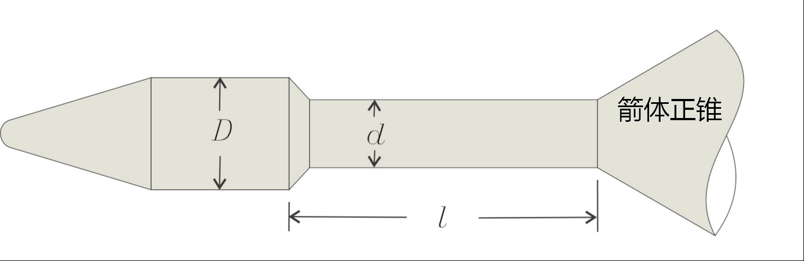

Fig.1 The diagram of shape parameter

Table 1 Three configurations with different D/d

|  |  |
| --- | --- |
| Configuration | D/d |
| Config. 1 | 1.73 |
| Config. 2 | 1.60 |
| Config. 3 | 1.55 |

# Experimental Principles

Buffeting test with elastic model involve two aspects: aerodynamic damping test and buffeting load response test. The aerodynamic damping test determines whether the additional aerodynamic damping of the launch vehicle's free-free bending vibration mode during flight is positive. If the aerodynamic damping is negative, the launch vehicle's response to vibration will increase, potentially leading to vibration divergence. The buffeting load response test involves measuring the strain response data of the first elastic mode to the free stream to assess the magnitude and duration of buffeting loads on the launch vehicle during the ascend flight. Since only the launch vehicle's free-free bending mode is considered, the launch vehicle structure can be simplified as a simple beam-mass model.

The aeroelastic equation can be expressed as Equation (1), where qi is generalized displacement of the i-th order mode, bi is the structural damping coefficient of the i-th order, ωi is the natural circular frequency of the i-th order, Mi is the corresponding generalized mass, and Gi is the generalized aerodynamic force[1,14].

 (1)

The right-hand side of the Equation 1 can be expressed by Taylor expansion as:

 (2)

Combining the two equations above, the aeroelastic equation can be expressed as:

 (3)

Generally, the aerodynamic stiffness Ki in the aeroelastic equation is negligible compared to the structural stiffness, while the aerodynamic damping coefficient cannot be ignored since it is of the same order of magnitude as the structural damping coefficient. By conducting wind tunnel tests to obtain the total damping coefficient bi_total and subtracting the structural damping coefficient bi obtained from GVT, the aerodynamic damping Bi of the launch vehicle can be obtained, i.e., Bi = bi_total - bi [1,14].

Buffeting load response test was conducted to measure the bending strain of the model at a certain axial station. The deformation is the combination of the response of several free-free bending modes of the launch vehicle. The incoming flow in the wind tunnel test varies continuously from the Mach number of 0 to 1.1, which realistically reflects the launch vehicle's flight state. By measuring the strain gauge response amplitude and response time data of the test model to the free stream, the magnitude of buffeting loads on the launch vehicle during flight can be determined. The results of this test can provide a more intuitive reflection of the launch vehicle's buffeting response.

# Elastic Model Design

## Model Design Method

Buffeting tests of launch vehicle model in wind tunnels use elastic models that must satisfy both aerodynamic similarity and structural dynamic similarity, meaning that the model's structural modes and frequencies must meet certain similarity requirements. The design of the model is based on stiffness distribution obtained according to the scaling laws and is adjusted by adding ballast to ensure the similarity of mode shape and frequency. The specific design steps are as follows: 1) Establish similarity ratios and scaled model parameters based on flight trajectory parameters and wind tunnel parameters; 2) Design the elastic model based on the distribution section bending stiffness parameters and mass parameters of the model; 3) Perform structural dynamic analysis of the model and optimize the local mass and stiffness characteristics of the model.

## Similarity Criteria

Buffeting tests require ensuring the similarity of the model's mode shapes and frequencies to the actual vehicle. The design state of the elastic model is based on the ascent stage of the launch vehicle at Ma=0.88. The similarity relationships for elastic model design are shown in Table 2. Typically, length ratio KL, density ratio Kρ, and dynamic pressure ratio Kq are taken as basic ratios, and other parameters such as stiffness EI, mass W, and frequency f can all be expressed by these ratios.

In addition, the scaling of wind tunnel test models needs to consider the requirements of wind tunnel blockage and model strength to avoid damage during testing.

**Table 2 The design parameter of elastic model**

|  |  |  |  |
| --- | --- | --- | --- |
| Design parameters | | Scaling ratio | |
| Name | Unit | Name | Unit |
| v | m/s | Kv | Kρ-1/2*Kq1/2 |
| **ρ** | kg/m3 | Kρ | - |
| q | Pa | Kq | - |
| W | kg | Kw | Kρ*KL3 |
| L | mm | KL | - |
| f | Hz | Kf | Kρ-1/2*Kq1/2KL-1 |
| EI | N·m2 | KEI | Kq*KL4 |

## Model Verification

The design work of elastic models was carried out for the three launch vehicle configurations, and the models were verified using the Modal Assurance Criterion (MAC) value. The first-mode MAC value for the Config. 1 (D/d=1.73) can reach 0.98, and the second-mode MAC value is 0.83. A comparison of the elastic model and the real launch vehicle's first and second vibration modes for the Config. 1 (D/d=1.73) is shown in Figure 2, where the horizontal axis represents the normalized position station with maximum length, and the vertical axis represents the normalized vibration mode with maximum displacement.

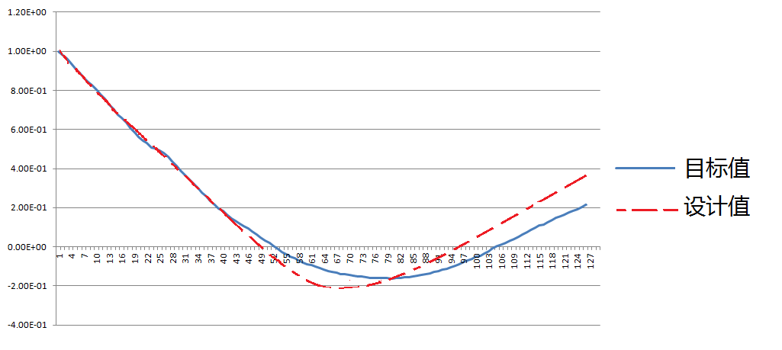

Fig.2 Mode shape of the 1st free-free bending mode

# Experimental Equipment

The flutter buffeting wind tunnel test of the medium-sized launch vehicle with a large-diameter fairing configuration in China was conducted in the FL-61 wind tunnel. This wind tunnel is a continuous transonic wind tunnel, with a slotted wall test section and a cross-sectional dimension of 0.6m × 0.6m.

The signal generator was used as the signal source to generate a sine wave signal, and a shaker was used to excite the model. During the test, the signal generator generated a fixed frequency (a certain low-order natural frequency of the model being tested) to drive the shaker to excite the model, and the power amplifier was adjusted to make the model vibrate to the required amplitude. The shaker was then turned off to allow the model to undergo free decay vibration. By measuring the response of the model's free decay, the damping value of that mode can be obtained.

# Data Analysis Methods and Theories

The damping identification of free vibration uses the ERA method. The ERA method, known as the Eigensystem Realization Algorithm, is a multi-input multi-output time-domain modal parameter identification method. It requires only a short amount of free response data to identify parameters, has a fast identification speed, and strong identification capabilities for low-frequency, dense frequency, and repeated frequency. Importantly, it can obtain the minimal realization of the system, which is convenient for control applications and is widely used in the aerospace field. This method originates from the minimum realization theory of Ho-Kalman in control theory. To improve noise resistance, Kung applied singular value decomposition to it, and in 1984, Juang first applied it to the field of structural dynamics [15,16].

The essence of the ERA algorithm is to use measured impulse response or free response data to find a minimal realization of the system through Hankel matrix and singular value decomposition, and transform this realization into a characteristic canonical form.

For an n-dimensional linear system with m inputs and p outputs, the discrete-time state equation is given by:

 (4)

where X(k) is the state variable, G, B, and C are the system matrix, control matrix, and observation matrix, respectively. The structure of the system response data is as follows:

 (5)

The ERA algorithm can identify dense and repeated frequency modes using response data from multiple initial states. Construct the Hankel matrix as equation (6).

 (6)

Perform singular value decomposition on Hrs(0), where P and V are the left and right singular vector matrices, and D is a diagonal matrix with elements arranged in descending order.

 (7)

 (8)

Finally, perform an eigenvalue decomposition on matrix G to obtain the modal parameters of the system. The aerodynamic damping effect is entirely attributed to the phase difference between the generalized aerodynamic force and modal vibration, as shown in equation (9), where M is the generalized mass and A is the amplitude.

 (9)

# Experimental Results Analysis

## Aerodynamic Damping Test Results

In the aerodynamic damping test, an electromagnetic vibration shaker was used to excite the model at the frequencies corresponding to the first and second-order models, and after stabilization, the shaker was disconnected to measure the vibration decay signal. Each state was excited 6 times (to eliminate random effects), and the average damping bi_total was obtained. The aerodynamic damping Bi is then calculated as bi_total - bi. The Mach number range of the test was 0.7 to 1.1, and the angle of attack range was 0° to 6°.

The aerodynamic damping wind tunnel test results of the first free-free bending mode for the Config. 1 (D/d=1.73) is shown in Figure 3. It can be seen that the aerodynamic damping for this configuration in the Mach number range of 0.7 to 1.05 are positive, with no negative damping observed.

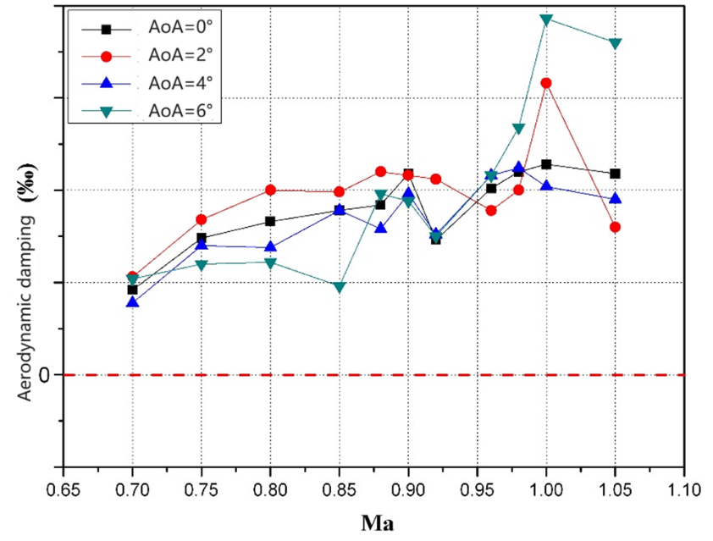

Fig.3 The aerodynamic damping of first-order elastic model of Configuration 1

The wind tunnel test results of first free-free bending mode for the Config. 2 (D/d=1.60) is shown in Figure 4. It is shown that the aerodynamic damping for this configuration in the Mach number range of 0.7 to 1.05 is positive.

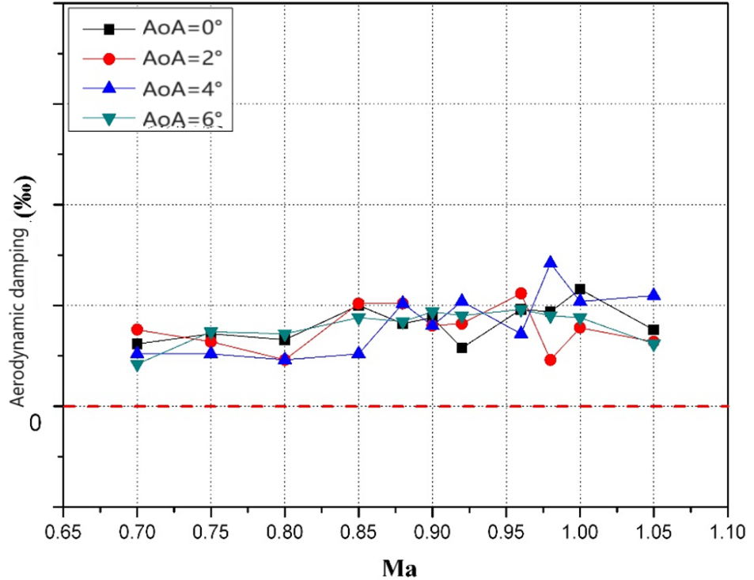

Fig.4 The aerodynamic damping of first-order elastic model of Configuration 2

The wind tunnel test results of first free-free bending mode for the Config. 3 (D/d=1.55) is shown in Figure 5. It can be seen that the aerodynamic damping for this configuration in the Mach number range of 0.7 to 1.05 is also positive.

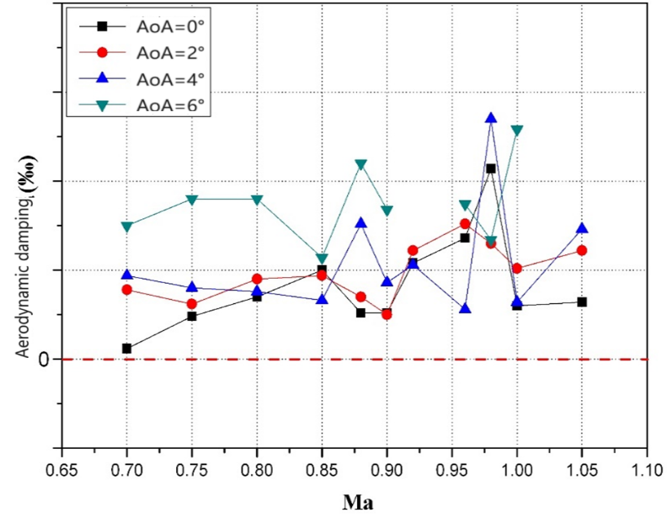

Fig.5 The aerodynamic damping of first-order elastic model of Configuration 3

Comparison of aerodynamic damping data for first free-free bending mode of three configurations shows that the Mach number range with smaller aerodynamic damping is 0.70 to 0.80, while the Mach number range with larger aerodynamic damping is 0.85 to 1.05. This is because at lower Mach numbers, especially below 0.70, strong shock waves have not yet formed on the surface of the launch vehicle body, particularly on the nose cone, resulting in weaker unsteady aerodynamic effects. After Mach number exceeds 0.85, strong shock waves gradually form starting from the front cone section of the launch vehicle fairing. These shock waves cause local oscillations on the launch vehicle body, leading to an increase in aerodynamic damping.

## Buffeting Load Test Results

The bending moment response of the first free-free bending mode of the three launch vehicle models to the incoming flow with Mach numbers continuously changed without shaker’s are compared in Figure 6.

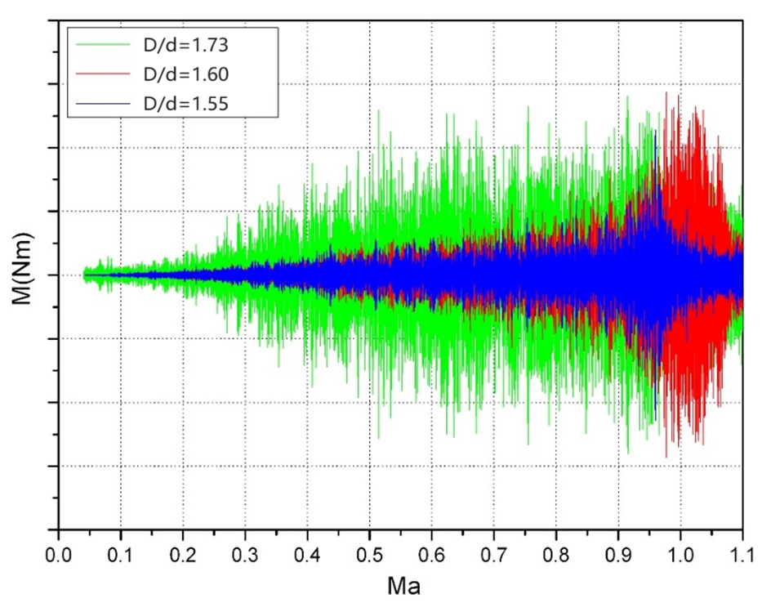

Fig.6 The comparison of bending moment response of the three configurations

From the figure, it can be seen that for the Config. 3 (D/d=1.55), the model's bending moment response is minimal at lower Mach numbers, gradually increasing with Mach number, and reaching a peak at Mach number 0.95. The Mach number range with significant model bending moment response is approximately 0.9 to 1.0.

The bending moment response of the Config. 2 (D/d=1.60) is similar to the Config. 3 (D/d=1.55), but the magnitude and Mach number range of the bending moment response are greater than the Config. 3 (D/d=1.55). The Mach number range with significant model bending moment response for this configuration is approximately 0.9 to 1.05.

The bending moment response of the Config. 1 (D/d=1.73) is different from the previous two configurations. The Mach number range with significant model bending moment response for this configuration is approximately 0.4 to 1.0. Typically, the buffeting issues of launch vehicles are caused by the effects of fluctuation pressure in the transonic regime during ascent. Therefore, the Mach number range for classical buffet research is usually 0.7 to 1.05. However, the bending moment response pattern of the Config. 1 (D/d=1.73) is notably different from the previous two configurations, with significant response amplitudes between the Mach number of 0.4 and 0.7, which attributed to unsteady flow excitation after the large fairing cone.

# Conclusions

Severe buffeting issues during the ascend flight of launch vehicles directly impact mission success. Therefore, it is crucial to address buffeting issues early in the conceptual design phase. Buffeting of a launch vehicle is a complex phenomenon which involves fluctuation pressure load and unsteady separation. Dynamic scaled model wind tunnel test is an effective method to identify the potential buffeting risks.

By conducting elastic model buffeting tests on three configurations with different diameters of fairing, it was concluded that the Config. 3 (D/d=1.55) meets the buffeting design standard, with lower buffeting risk compared to the other two configurations, which mitigates the overall buffeting risk of the project.

# References

[1] JI, Chen, WU, Yansen, HOU, Yingyu. Experimental study of aerodynamic damping characteristics of a launch vehicle with boosters in transonic flow[J]. Journal of Experiments in Fluid Mechanics. 2020, 34(6): 24-31.

[2] ZHAO, Rui, RONG, Jili, LI, Yuejun. An Investigation of Fluctuating Pressure Environment around Launch vehicle Fairing with Different Curvetypes[J]. ACTA ARMAMENTARⅡ 2017, 38(5): 1020-1026.

[3] NI, Jiamin. Review of aerodynamic design of China’s launch vehicle[C]. Proceedings of the Modern Aerodynamics Symposium. 2005.

[4] Cole, H. A, Jr., Erickson, A. L., and Rainey, A. G., Buffeting During Atmospheric Ascent[S]. NASA Space Vehicle Design Criteria. NASA SP-8001.1970. 11.

[5] Joao Luiz, F. Azevedo. Aeroelastic Analysis of Launch Vehicles in Transonic Flight[J]. Aeroelastica Analysis of Vehicles in Transonic Flight. 1989. Vol. 26, No. 1 14-23.

[6] LONG, Lehao. General design of liquid missile and launch vehicle[M]. Beijing: Aerospace Publishing Company, 1989.11, 546-548.

[7] Stanley R. Cole. Buffet Response of a Hammerhead Launch Vehicle Wind-Tunnel Model[J]. Journal of Spacecraft and Launch vehicles. Vol.29, No.3, May-June 1992.24-30.

[8] Andrew J. Sinclair and George T. Flowers. Low-Order Aeroelastic Model of Launch-Vehicle Dynamics[C]. AIAA Guidance, Navigation, and Control Conference. 2010 August, Toronto, Ontario Canada.

[9] Bombardier, G. D., Final Post-Test Report on Seven Percent Transonic Buffet Model for Various Titan Ⅲ Configurations, Mar-tin Co., Rept. SSD-CR-66-563, Denver, CO, Jan. 1967.

[10] FENG, Mingxi, WANG, Zhian. Experiments of transonic derivatives and buffeting of launch vehicle[J]. Journal of Astronautics, 1987(1): 55-62.

[11] Bai, Kui, Feng, Mingxi. Aeroelastic model and the buffet experimental technique[J]. Experiments and Measurements in Fluid Mechanics. 1999, 13(1): 38-42.

[12] JI, Chen, RAN, Jinghong, et al. The aerodynamic damping test of elastic launch vehicle model in transonic flow[C]. Proe of the 64th International Astronautical Congress. 2013

[13] JI, Chen, WU, Yansen, He, Gang, et al. Experimental study on aerodynamic damping wind tunnel of launch vehicle[C]. Proceedings of the 12th National Aeroelasticity Conference. 2011.

[14] LIU, Ziqiang. Transonic aerodynamics- Non-damped phenomenon of elastic coupling[D]. China Academy of Aerospace Aerodynamics. 2001.

[15] JUANG Jernan and Richard S., Pappa. An Eigensystem Realization Algorithm for Modal Parameter Identification and Model Reduction[J]. Modal Parameter Identification and Model Reduction. VOL. 8, NO. 5 620-627

[16] Gilbert, E.G., Controllability and Observability in Multivariable Control Systems. SIAM Journal on Control, Vol.1(2), 1963, 128-151.

# Copyright Statement

The authors confirm that they, and/or their company or organisation, hold copyright on all of the original material included in this paper. The authors also confirm that they have obtained permission from the copyright holder of any third-party material included in this paper to publish it as part of their paper. The authors confirm that they give permission, or have obtained permission from the copyright holder of this paper, for the publication and public distribution of this paper as part of the IFASD 2024 proceedings or as individual off-prints from the proceedings.